

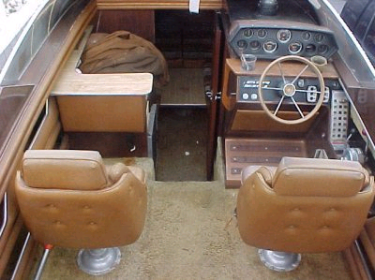

1979 CV27
Name: Chris Kochmann
Address: 142 S. Mt. Vernon Ave.
City: Prescott
State: az
Zip: 86303
Email Address: ckochmann@msn.com
Phone Number: 602-622-3777
Serial Number: gcv12048m79a

